Activity Diagram:
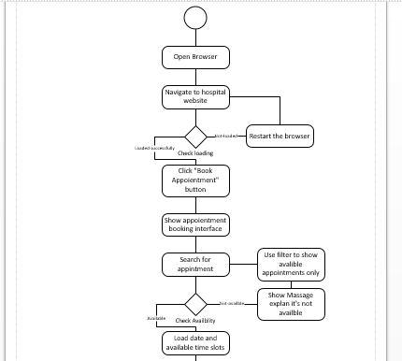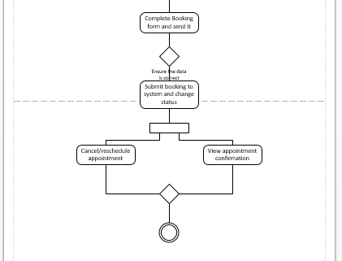

Use cases Diagram:
Actors: Patient, Confirmation System, and Admin.
Required resources: Laptop, Visio, Word.

